File Mode
# Source: AI Source: Provided by: [Data Path: Persons Table -> ID Column: 1, Name_En Column: Motasem Essam] -> From: [Chatgpt (GPT‑5 Mini)] on [12/10/2025]
In computing, File Mode refers to the way in which a file is opened, which determines what operations can be performed on the file—whether you can read from it, write to it, or both.
Think of it as setting the “permissions” or “mode” for interacting with a file when a program opens it.

Common File Modes
# Source: AI Source: Provided by: [Data Path: Persons Table -> ID Column: 1, Name_En Column: Motasem Essam] -> From: [Chatgpt (GPT‑5 Mini)] on [12/10/2025]
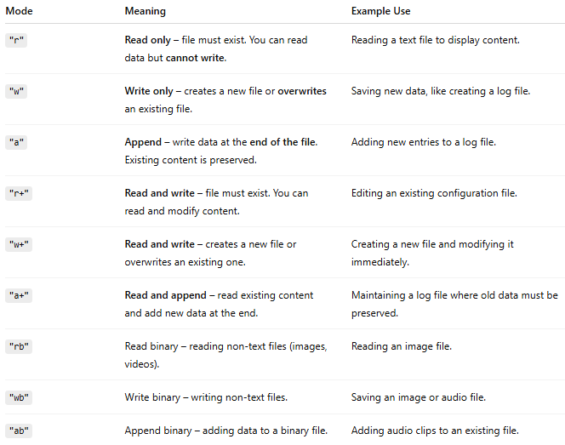
Mode | Meaning | Example Use
"r" | Read only – file must exist. You can read data but cannot write. | Reading a text file to display content.
"w" | Write only – creates a new file or overwrites an existing file. | Saving new data, like creating a log file.
"a" | Append – write data at the end of the file. Existing content is preserved. | Adding new entries to a log file.
"r+" | Read and write – file must exist. You can read and modify content. | Editing an existing configuration file.
"w+" | Read and write – creates a new file or overwrites an existing one. | Creating a new file and modifying it immediately.
"a+" | Read and append – read existing content and add new data at the end. | Maintaining a log file where old data must be preserved.
"rb" | Read binary – reading non-text files (images, videos). | Reading an image file.
"wb" | Write binary – writing non-text files. | Saving an image or audio file.
"ab" | Append binary – adding data to a binary file. | Adding audio clips to an existing file.

Key Points
# Source: AI Source: Provided by: [Data Path: Persons Table -> ID Column: 1, Name_En Column: Motasem Essam] -> From: [Chatgpt (GPT‑5 Mini)] on [12/10/2025]
- File mode is specified when opening a file (e.g., using open() in Python or fopen() in C).
- Choosing the correct mode ensures:
  - You don’t accidentally overwrite a file.
  - You can perform the operations you need (read, write, append).

Example in Python
# Source: AI Source: Provided by: [Data Path: Persons Table -> ID Column: 1, Name_En Column: Motasem Essam] -> From: [Chatgpt (GPT‑5 Mini)] on [12/10/2025]
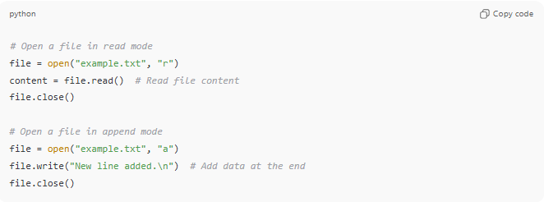
# Open a file in read mode
file = open("example.txt", "r")
content = file.read() # Read file content
file.close()

# Open a file in append mode
file = open("example.txt", "a")
file.write("New line added.\n") # Add data at the end
file.close()

💡 Analogy:
# Source: AI Source: Provided by: [Data Path: Persons Table -> ID Column: 1, Name_En Column: Motasem Essam] -> From: [Chatgpt (GPT‑5 Mini)] on [12/10/2025]
- "r" → Reading a book in a library (you can only read, not write)
- "w" → Taking a blank notebook and writing in it (old content erased)
- "a" → Adding pages to the end of your notebook without erasing anything

